BAVARIAN COOKING
Made Simple
Rev 11 — Polished Edition
121 Photographed Recipes Inspired by Bavaria & Southern Germany
Beyond the Oktoberfest
Anneliese Tauber
99 Luftballon Publishing · Passau, Germany

Before You Cook
Quantities and times. Every recipe serves 4 unless noted (cakes and bakes list their yield). Amounts are given in both US and metric units; weigh ingredients with a kitchen scale for the most reliable results. Oven temperatures are for conventional ovens; lower them by about 20 °C (35 °F) for fan ovens. Cooking times are guides—ovens, pans, and ingredients vary.
Meat, poultry, and fish. Cook all poultry, including stuffing, to 74 °C (165 °F). Cook ground meat and sausage to 71 °C (160 °F). Cook pork chops, roasts, and other whole cuts to 63 °C (145 °F) and rest 3 minutes; cook ground pork to 71 °C (160 °F). Use a food thermometer. Do not rinse raw poultry; pat it dry and wash hands and surfaces after handling. Beef tartare, soft-cooked egg yolks, and mousse-style desserts use raw or lightly cooked eggs and meat: keep them cold and avoid them for pregnant women, small children, older adults, and anyone with a weakened immune system.
Hot oil and sugar. Frying and caramel reach very high temperatures. Never leave hot oil unattended, keep water away from it, and keep children out of the kitchen.
Alcohol. Mulled wine, Jägertee, grog, and some sauces and sorbets contain wine, beer, rum, or spirits. Boiling reduces but does not remove the alcohol.
Allergens. Many recipes contain gluten (wheat, rye, barley), milk, eggs, tree nuts, soy, celery, mustard, fish, shellfish, sesame, poppy seeds, and sulfites. Read ingredient lists and packaged-product labels, and adapt recipes to your needs.
Guten Appetit! Adjust seasoning to your taste.

Welcome to Bavaria’s Table
Oktoberfest may be Bavaria’s best-known celebration, but it is only one part of the region’s food story. Everyday tables, bakeries, beer gardens, and family celebrations offer many more ways to meet Bavarian cooking. A snack board, a Sunday roast, a bowl of dumplings, and a slice of fruit cake each open a different door.
The recipes also sketch a wider map: Franconian roast pork, a Munich schnitzel, and Allgäuer Cordon Bleu sit alongside neighboring Southern German and Alpine influences. This is a recipe collection, not a full history of the region, but its dishes and German names offer a welcoming way to explore. Browse by appetite, season, or curiosity; there is no required route through the book.

A Fun Fact About the Wiesn
The first Oktoberfest in 1810 was a horse race celebrating the wedding of Crown Prince Ludwig and Princess Therese. The meadow where it took place was later named Theresienwiese in her honor; locals shorten that to “Wiesn,” Bavarian for “meadow.” So the festival began with a wedding, a race, and a patch of grass—long before the modern beer tents.

Your First Bavarian Table
Begin with a Brotzeit. Arrange pretzels or bread with cheese, radishes, and pickles. Store-bought items are welcome; the point is to make a relaxed shared plate, not a test.
Make one thing yourself. Try the Bavarian cheese spread (Obatzda). Mash softened Camembert or Brie with butter, onion, and paprika, then season and chill it.
Sit down and enjoy it. Add the spread to your board with the bread and vegetables. You have made a Bavarian-inspired meal without turning the first attempt into an all-day project.

Sample Polished Recipes (Rev 11 Standard)

Beer Soup
Biersuppe
Serves 4
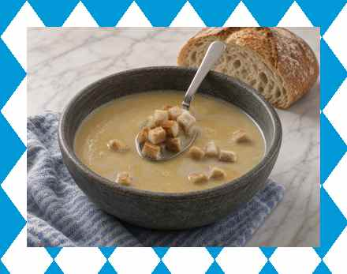
A silky golden soup in which light beer, cream, and a whisper of nutmeg do the talking. Croutons supply the crunch.
Ingredients
- 500 ml (2 cups) light beer (lager or wheat beer)
- 500 ml (2 cups) water
- 200 ml (¾ cup) heavy cream
- 2 Tbsp butter
- 2 Tbsp all-purpose flour
- 1 large onion, finely chopped
- 2 garlic cloves, minced
- 2 egg yolks
- Salt and pepper
- Pinch of nutmeg
- Fresh chives or parsley, chopped
- Croutons, optional
Instructions
1. In a large pot, melt the butter over medium heat. Cook the onion until soft and translucent, 5–7 minutes. Add the garlic and cook 1 minute more.
2. Sprinkle the flour over the onions and garlic and stir constantly to form a roux. Cook 2 minutes.
3. Gradually whisk in the beer and water until smooth. Simmer 15 minutes, stirring occasionally.
4. Stir in the cream and simmer another 5–10 minutes.
5. In a small bowl, whisk the egg yolks. Ladle a little hot soup into the yolks, whisking constantly to temper them. Slowly pour the mixture back into the pot, whisking constantly.
6. Season with salt, pepper, and nutmeg. Heat gently without boiling until the soup thickens slightly. Ladle into bowls, garnish with herbs, and serve with croutons if desired.

Bavarian Cheese Spread
Obatzda
Serves 4
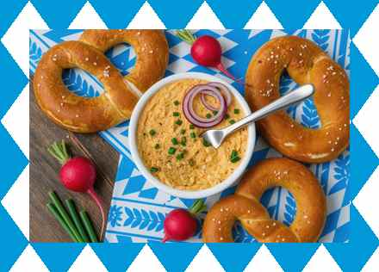
For a Munich-style Brotzeit, mash ripe Camembert with butter, onion, and paprika. Serve with pretzels and radishes.
Ingredients
- 230 g (8 oz) ripe Camembert or Brie, cut into pieces
- 45 g (1½ oz) butter, softened
- 1–2 Tbsp cream cheese or sour cream
- 1–2 Tbsp wheat beer, optional
- 1 small onion, finely chopped
- 2 tsp mild paprika
- 1 tsp caraway seeds, optional
- Salt and pepper
- Fresh chives, chopped
- Radishes and pretzels, for serving
Instructions
1. Mash the cheese with the softened butter and cream cheese (or sour cream) until smooth.
2. Stir in the onion, paprika, and caraway if using. Add a splash of beer for looseness if desired.
3. Season with salt and pepper; it should be creamy, tangy, and gently spiced.
4. Cover and refrigerate at least 1 hour. Bring to room temperature before serving, garnish with chives, and serve with radishes and pretzels.

Weißwurst with Sweet Mustard and Pretzel
Weißwurst mit süßem Senf und Brezn
Serves 4
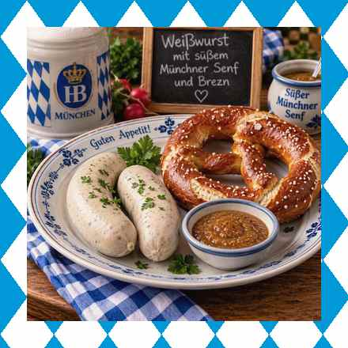
A Munich second-breakfast classic. Tradition holds that Weißwurst should not be on the table after noon.
Ingredients
- 8 fresh Weißwürste
- 4 soft pretzels
- Wheat beer, for serving
Sweet mustard
- 5 Tbsp mild yellow mustard
- 1 Tbsp honey
- 1 Tbsp light brown sugar
- 1 tsp apple-cider vinegar
Instructions
1. Bring about 2 L (8¼ cups) water to a boil, then remove from the heat and cool to about 75 °C (165 °F)—hot and steaming, but no bubbles.
2. Add the Weißwürste without piercing them, cover, and steep 10 minutes. Never boil them or the skins will burst.
3. Stir the mustard, honey, brown sugar, and vinegar until smooth; let stand 10 minutes.
4. Serve the sausages in a warmed bowl with a little of the hot water, the sweet mustard, pretzels, and wheat beer. To eat them the traditional way, cut lengthwise and peel the skin away, or suck the filling out of the skin (zuzeln). The skin is not eaten.

About This Edition
This Rev 11 sample demonstrates the polished standard: clean dual-unit ingredient lists, numbered instructions, consistent formatting, and lightly vivid prose that remains practical. Apply the same style across all 121 recipes for a complete, professional cookbook.
Guten Appetit!

